Final Practice Test

Name: Tiwouw, Joseph Janone (lastname, firstname middlename)

Student ID : s21930003 (e.g. s100xxxxx)

Class : DBMS A

1. What privilege should a user be given to log on to the Oracle server? Is this a system privilege or an object privilege?

create session system privilege

2. What privilege should a user be given to create tables?

create table privilege

3. If you create a table, who can pass along privileges to other users on your table?

anyone who’s given privilege from using with grant option

4. You are the DBA. You are creating many users who require the same system privileges.

What should you use to make your job easier?

make a role that contain the system privilege and grant privilege the role to user

5. What command do you use to change your password?

alter user statement

6.User1 is the owner of the EMP table and grants the DELETE privilege to User2 by using the WITH GRANT OPTION clause. User2 then grants the DELETE privilege on EMP to User3. User1 now finds that User3 has the privilege and revokes it from User2. Which user can now delete from the EMP table?

just user 1

7.You want to grant SCOTT the privilege to update data in the DEPARTMENTS table. You also want to enable SCOTT to grant this privilege to other users. What command do you use?

grant update to on departments to SCOTT with grant option;

8.Grant another user query privilege on your table. Then, verify whether that user can utilize the privilege.

**Note:** In this example, you may use hr user, and grant to another user (create any user as you want) the query privilege on any of your table (you may create any table as you want).

a. Grant another user privilege to view records in your REGIONS table. Include an option for this user to further grant this privilege to other users.

b. Have the user query your REGIONS table.

c. Have the user pass on the query privilege to a third user (for example, user3).

d. Take back the privilege from the user who performs step b

.

a.

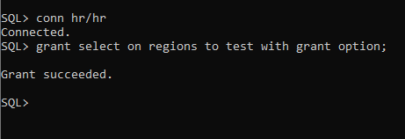

b.

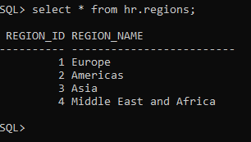

c. grant select on <team1_dbs>,regions to <team3_dbs>;

d.

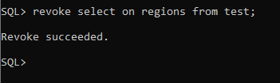

**Note:** For exercises 11 through 17, use several users

9. Grant another user query and data manipulation privileges on your COUNTRIES table. Make sure that the user cannot pass on these privileges to other users.

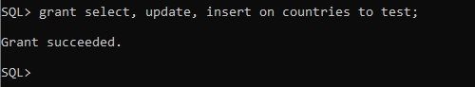

10. Take back the privileges on the COUNTRIES table granted to another user.

**Note:** For exercises 11 through 17, pretend you have several team (Team1 and Team2)

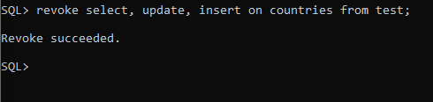

11. Grant another user access to your DEPARTMENTS table. Have the user grant you query access to his or her DEPARTMENTS table.

Team 1 : execute the grant statement.

grant select

on departments

to user2

Team 2 : execute the GRANT statement.

grant select

on departments

to user1

12. Query all the rows in your DEPARTMENTS table.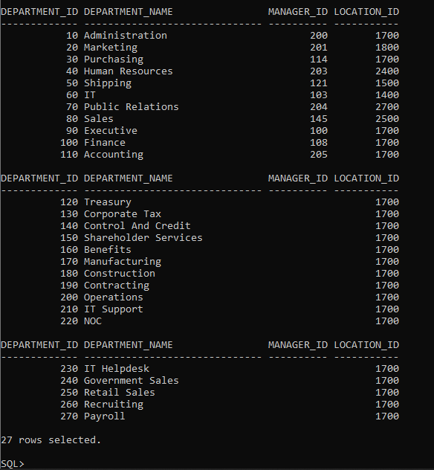

13. Add a new row to your DEPARTMENTS table. Team 1 should add Education as department number 500. Team 2 should add Human Resources as department number 510. Query the other team’s table.

Team 1

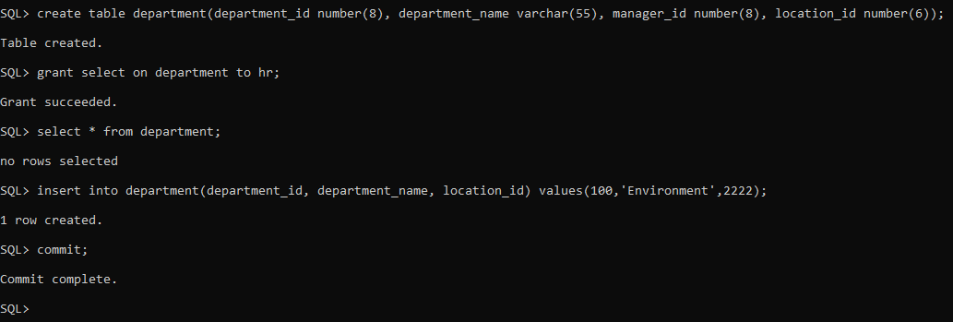

Team 2

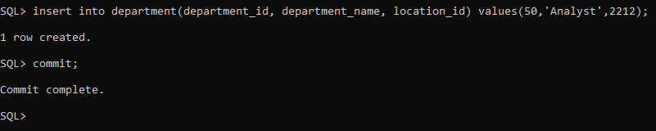

14. Create a synonym for the other team’s DEPARTMENTS table.

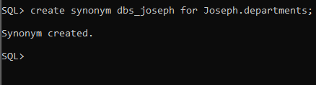

15.Query all the rows in the other team’s DEPARTMENTS table by using your synonym.

select * from dbs_joseph;

16. Revoke the SELECT privilege from the other team.

Team 1:

revoke select

on departments

from user1;

Team 2:

revoke select

on departments

from user2;

17. Remove the row you inserted into the DEPARTMENTS table in step 13 and save the changes.

